Projection of a Line Segment
# Source: AI Source: Provided by: [Data Path: Persons Table -> ID Column: 1, Name_En Column: Motasem Essam] -> From: [ChatGPT] on [7/25/2026]
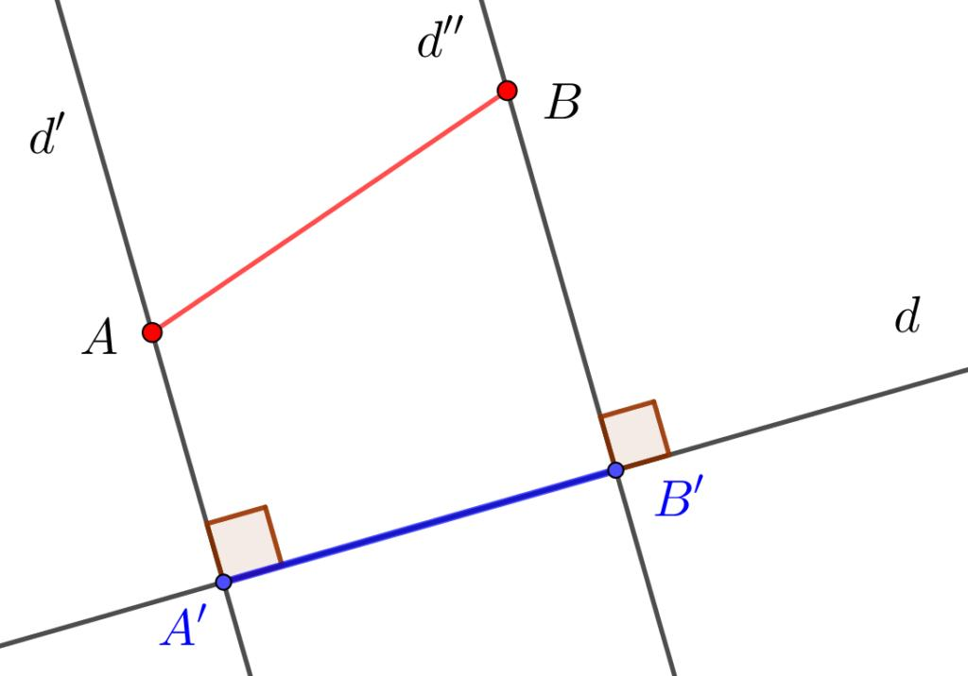
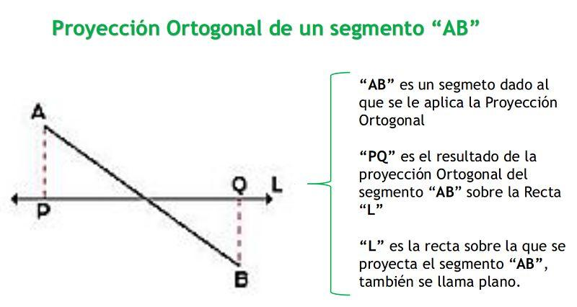
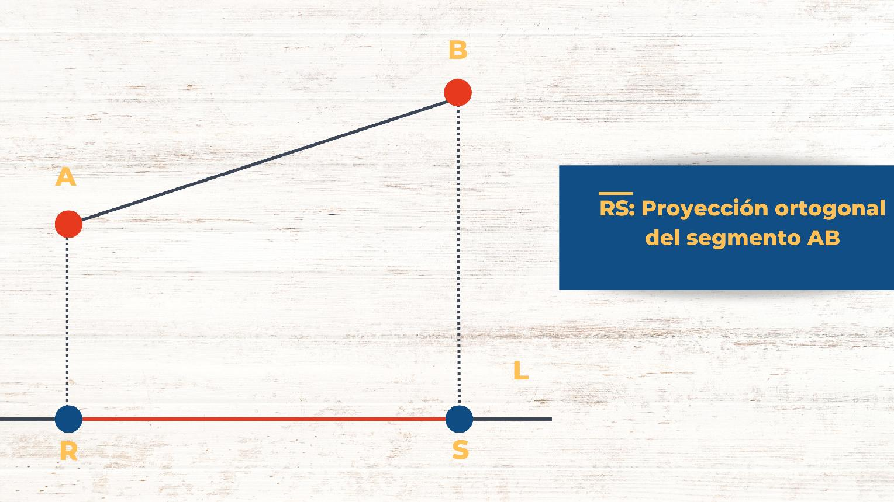

Definition
# Source: AI Source: Provided by: [Data Path: Persons Table -> ID Column: 1, Name_En Column: Motasem Essam] -> From: [ChatGPT] on [7/25/2026]
The projection of a line segment is the segment formed by projecting the two endpoints of the original segment onto a target line or plane.
For a line segment $\overline{AB}$, let:
- $A^{'}$ be the projection of $A$.
- $B^{'}$ be the projection of $B$.
Then the projection of $\overline{AB}$ is:
$$\boxed{\overline{A^{'}B^{'}}}$$
For an orthogonal projection, the projection lines are perpendicular to the target:
$$\boxed{AA^{'}⟂l}$$
and:
$$\boxed{BB^{'}⟂l}$$
where $l$ is the projection line.

Purpose
# Source: AI Source: Provided by: [Data Path: Persons Table -> ID Column: 1, Name_En Column: Motasem Essam] -> From: [ChatGPT] on [7/25/2026]
Projection of a line segment is used to:
- Determine the component of a segment in a particular direction.
- Find the projected length of a segment.
- Simplify geometric figures.
- Analyze distances and directions.
- Solve problems involving perpendiculars.
- Represent 3D objects on 2D surfaces.
- Resolve vectors into components.

Basic Configuration
# Source: AI Source: Provided by: [Data Path: Persons Table -> ID Column: 1, Name_En Column: Motasem Essam] -> From: [ChatGPT] on [7/25/2026]
Consider segment $\overline{AB}$ and a projection line $l$.
The endpoints $A$ and $B$ are projected onto $l$:
$A→A^{'}$ $B→B^{'}$
The resulting segment is:
$\boxed{\overline{A^{'}B^{'}}}$
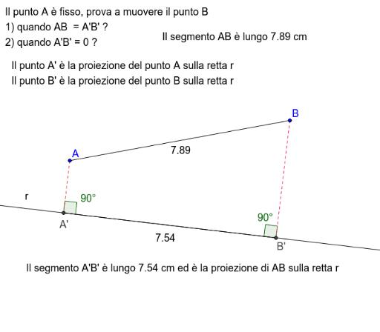
For an orthogonal projection:
$AA^{'}⟂l$ $BB^{'}⟂l$

Mathematical Representation
# Source: AI Source: Provided by: [Data Path: Persons Table -> ID Column: 1, Name_En Column: Motasem Essam] -> From: [ChatGPT] on [7/25/2026]
If the original segment has length:
$$AB$$
and makes an angle $θ$ with the projection line, then its orthogonal projection has length:
$$\boxed{A^{'}B^{'}=AB|cosθ|}$$
If:
$$0^{∘}≤θ≤{90}^{∘}$$
then:
$$\boxed{A^{'}B^{'}=ABcosθ}$$
Thus:
$$\boxed{\text{Projected Length}=\text{Original Length}×|cosθ|}$$

Example 1 — Simple Projection
# Source: AI Source: Provided by: [Data Path: Persons Table -> ID Column: 1, Name_En Column: Motasem Essam] -> From: [ChatGPT] on [7/25/2026]
Suppose:
$$AB=10$$
and the angle between $AB$ and the projection line is:
$${60}^{∘}$$
Then:
$$A^{'}B^{'}=ABcos{60}^{∘}$$
Since:
$$cos{60}^{∘}=\frac{1}{2}$$
we get:
$$A^{'}B^{'}=10\left(\frac{1}{2}\right)$$
Therefore:
$$\boxed{A^{'}B^{'}=5}$$

Example 2 — Segment Parallel to the Projection Line
# Source: AI Source: Provided by: [Data Path: Persons Table -> ID Column: 1, Name_En Column: Motasem Essam] -> From: [ChatGPT] on [7/25/2026]
Suppose:
$$AB=12$$
and:
$$AB∥l$$
Then:
$$θ=0^{∘}$$
Therefore:
$A^{'}B^{'}=12cos0^{∘}$ $A^{'}B^{'}=12(1)$
So:
$$\boxed{A^{'}B^{'}=12}$$
Conclusion
A segment parallel to the projection line projects to a segment with the same length.
$$\boxed{A^{'}B^{'}=AB}$$

Example 3 — Segment Perpendicular to the Projection Line
# Source: AI Source: Provided by: [Data Path: Persons Table -> ID Column: 1, Name_En Column: Motasem Essam] -> From: [ChatGPT] on [7/25/2026]
Suppose:
$$AB=8$$
and:
$$AB⟂l$$
Then:
$$θ={90}^{∘}$$
Therefore:
$$A^{'}B^{'}=8cos{90}^{∘}$$
Since:
$$cos{90}^{∘}=0$$
we get:
$$\boxed{A^{'}B^{'}=0}$$
Both endpoints project to the same point.
Thus, the entire segment collapses to a single point.

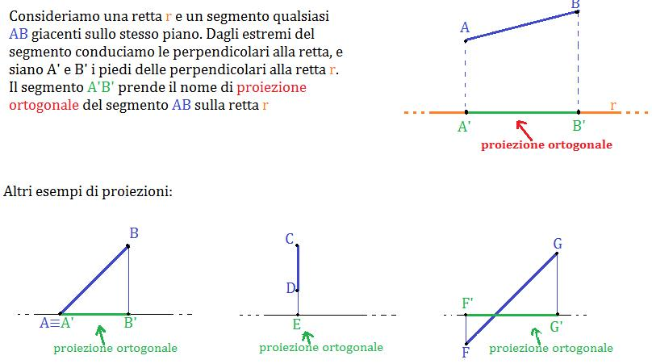

Example 4 — Coordinate Geometry
# Source: AI Source: Provided by: [Data Path: Persons Table -> ID Column: 1, Name_En Column: Motasem Essam] -> From: [ChatGPT] on [7/25/2026]
Suppose:
$$A=(2,5)$$
and:
$$B=(8,9)$$
We project the segment onto the $x$-axis.
For a point:
$$(x,y)$$
its orthogonal projection onto the $x$-axis is:
$$(x,0)$$
Therefore:
$$A^{'}=(2,0)$$
and:
$$B^{'}=(8,0)$$
The projected length is:
$A^{'}B^{'}=|8-2|$ $\boxed{A^{'}B^{'}=6}$
The original segment has length:
$AB=\sqrt{(8-2)^{2}+(9-5)^{2}}$ $=\sqrt{36+16}$ $=\sqrt{52}$ $=2\sqrt{13}$
So the projection is shorter:
$$\boxed{A^{'}B^{'}=6<2\sqrt{13}}$$

Projection onto the Coordinate Axes
# Source: AI Source: Provided by: [Data Path: Persons Table -> ID Column: 1, Name_En Column: Motasem Essam] -> From: [ChatGPT] on [7/25/2026]
For a segment:
$A=(x_{1},y_{1})$ $B=(x_{2},y_{2})$

Projection onto the $x$-axis
# Source: AI Source: Provided by: [Data Path: Persons Table -> ID Column: 1, Name_En Column: Motasem Essam] -> From: [ChatGPT] on [7/25/2026]
The endpoints become:
$A^{'}=(x_{1},0)$ $B^{'}=(x_{2},0)$
Therefore:
$$\boxed{A^{'}B^{'}=|x_{2}-x_{1}|}$$

Projection onto the $y$-axis
# Source: AI Source: Provided by: [Data Path: Persons Table -> ID Column: 1, Name_En Column: Motasem Essam] -> From: [ChatGPT] on [7/25/2026]
The endpoints become:
$A^{'}=(0,y_{1})$ $B^{'}=(0,y_{2})$
Therefore:
$$\boxed{A^{'}B^{'}=|y_{2}-y_{1}|}$$
This gives a useful interpretation:
$\boxed{\text{x-projection}=\text{horizontal component}}$ $\boxed{\text{y-projection}=\text{vertical component}}$

Projection and Right Triangles
# Source: AI Source: Provided by: [Data Path: Persons Table -> ID Column: 1, Name_En Column: Motasem Essam] -> From: [ChatGPT] on [7/25/2026]
The projection formula comes directly from trigonometry.
Suppose segment $AB$ has length $L$ and makes an angle $θ$ with the projection line.
The projection $A^{'}B^{'}$ is the adjacent side of a right triangle.
Therefore:
$$cosθ=\frac{A^{'}B^{'}}{AB}$$
Rearranging:
$\boxed{A^{'}B^{'}=ABcosθ}$
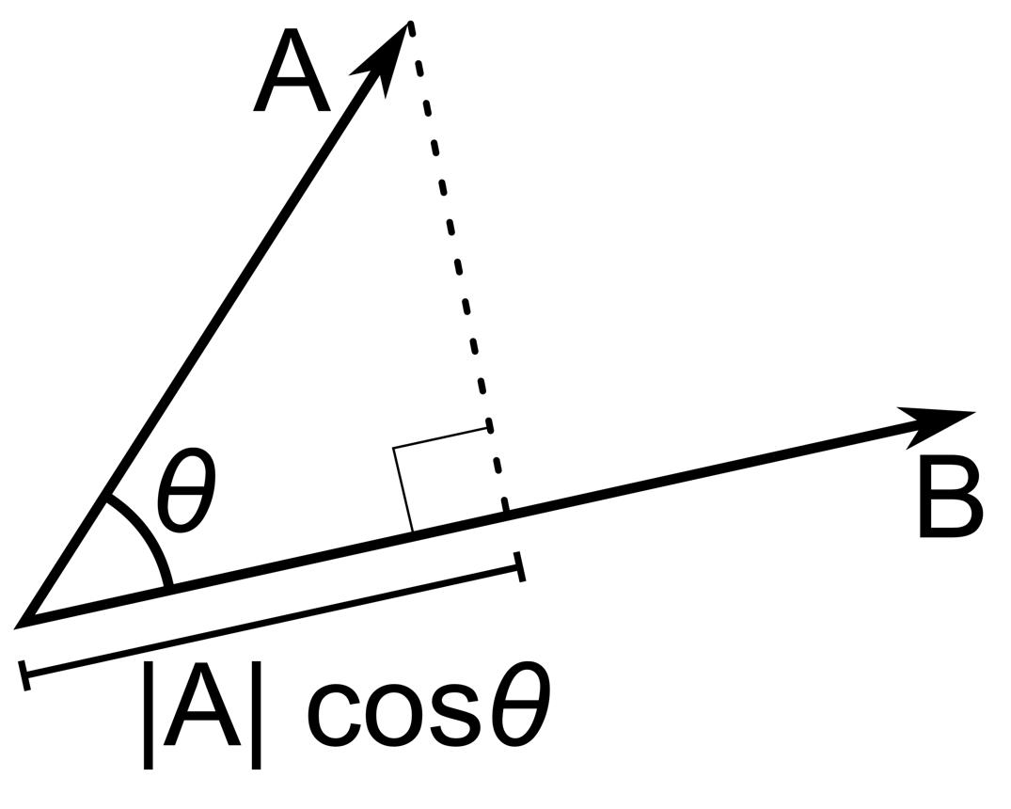
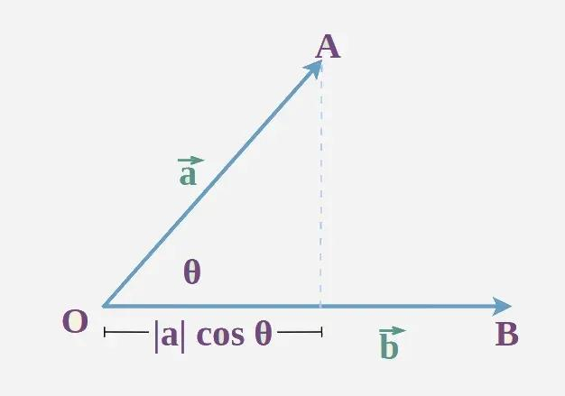
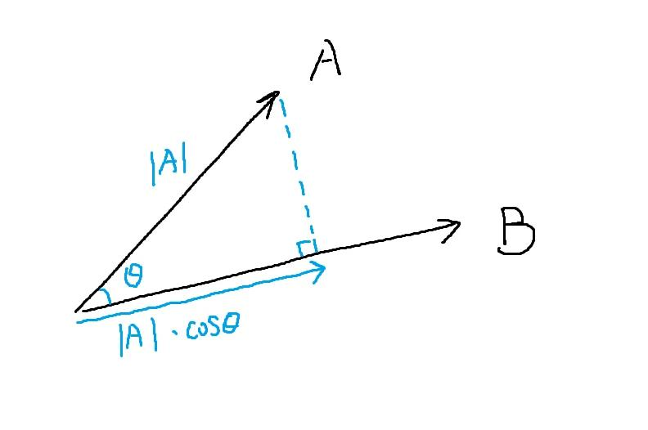

Important Properties

1. Projection length cannot normally exceed the original length
# Source: AI Source: Provided by: [Data Path: Persons Table -> ID Column: 1, Name_En Column: Motasem Essam] -> From: [ChatGPT] on [7/25/2026]
Because:
$$|cosθ|≤1$$
we have:
$$\boxed{A^{'}B^{'}≤AB}$$
for orthogonal projection.

2. Equal length occurs when the segment is parallel
# Source: AI Source: Provided by: [Data Path: Persons Table -> ID Column: 1, Name_En Column: Motasem Essam] -> From: [ChatGPT] on [7/25/2026]
If:
$$θ=0^{∘}$$
then:
$$cos0^{∘}=1$$
so:
$$\boxed{A^{'}B^{'}=AB}$$

3. Zero projection occurs when the segment is perpendicular
# Source: AI Source: Provided by: [Data Path: Persons Table -> ID Column: 1, Name_En Column: Motasem Essam] -> From: [ChatGPT] on [7/25/2026]
If:
$$θ={90}^{∘}$$
then:
$$cos{90}^{∘}=0$$
so:
$$\boxed{A^{'}B^{'}=0}$$

4. Projection preserves straightness
# Source: AI Source: Provided by: [Data Path: Persons Table -> ID Column: 1, Name_En Column: Motasem Essam] -> From: [ChatGPT] on [7/25/2026]
The projection of a line segment onto a line or plane remains a line segment, although it can degenerate into a point.

5. Orthogonal projection does not generally preserve angles
# Source: AI Source: Provided by: [Data Path: Persons Table -> ID Column: 1, Name_En Column: Motasem Essam] -> From: [ChatGPT] on [7/25/2026]
The angle between projected objects can differ from the original angle.
Therefore:
$$\boxed{\text{Projection is generally not angle-preserving}}$$

Vector Interpretation
# Source: AI Source: Provided by: [Data Path: Persons Table -> ID Column: 1, Name_En Column: Motasem Essam] -> From: [ChatGPT] on [7/25/2026]
A line segment can also be represented by a vector:
$$\vec{AB}$$
Its projection onto a direction represented by vector $\vec{u}$ is:
$$\boxed{{proj}_{\vec{u}}\vec{AB}=\frac{\vec{AB}⋅\vec{u}}{∥\vec{u}∥^{2}}\vec{u}}$$
If $\vec{u}$ is a unit vector:
$$∥\vec{u}∥=1$$
then:
$$\boxed{{proj}_{\vec{u}}\vec{AB}=(\vec{AB}⋅\vec{u})\vec{u}}$$
The corresponding scalar projected length is:
$$\boxed{|\vec{AB}⋅\vec{u}|}$$
for a unit direction vector.

Relationship with Triangle Altitude
# Source: AI Source: Provided by: [Data Path: Persons Table -> ID Column: 1, Name_En Column: Motasem Essam] -> From: [ChatGPT] on [7/25/2026]
Projection of a line segment is closely related to triangle altitude.
Suppose $A$ is a vertex of triangle $ABC$, and $A$ is projected orthogonally onto $BC$ at $D$:
$$AD⟂BC$$
Then:
$$\boxed{D=\text{projection of }A\text{ onto }BC}$$
and:
$\boxed{AD=\text{altitude of }△ABC}$
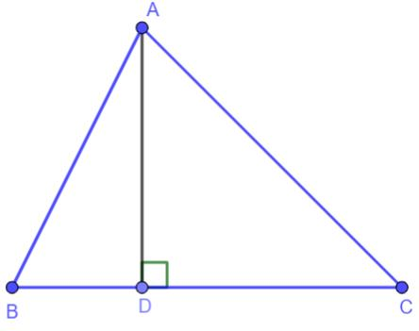
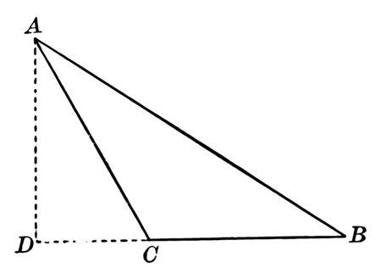
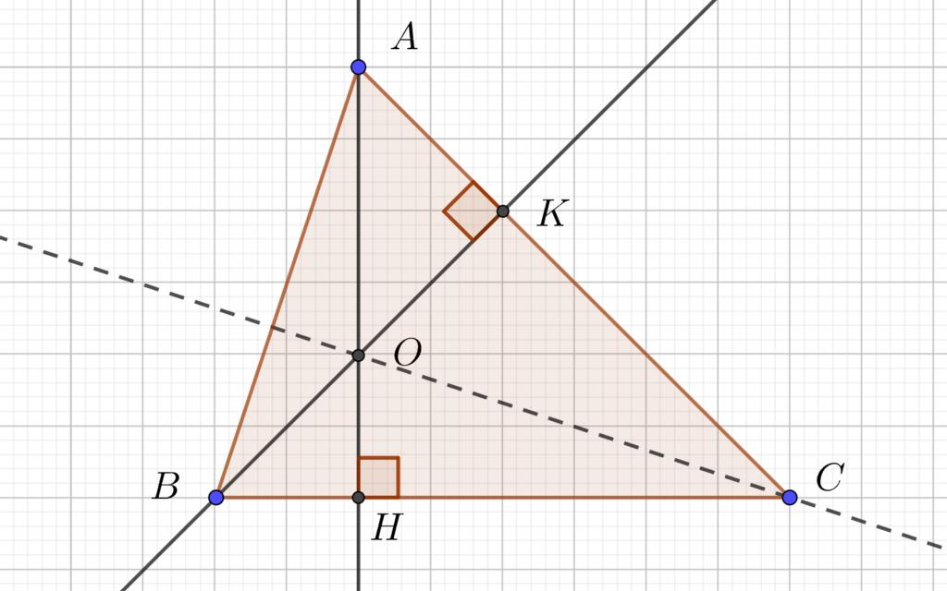
This gives an important connection:
$$\boxed{\text{Orthogonal Projection}→\text{Perpendicular Foot}→\text{Altitude}}$$

Relationship with Segment Addition
# Source: AI Source: Provided by: [Data Path: Persons Table -> ID Column: 1, Name_En Column: Motasem Essam] -> From: [ChatGPT] on [7/25/2026]
Projection can also be related to the components of a segment.
Suppose:
$$A-B-C$$
and the segment is projected onto a line.
The projected parts satisfy the same additive relationship:
$$\boxed{A^{'}B^{'}+B^{'}C^{'}=A^{'}C^{'}}$$
provided the projected points occur in the corresponding order.
Thus, projection is compatible with the addition of consecutive collinear segments.

Orthogonal Projection vs. Oblique Projection
# Source: AI Source: Provided by: [Data Path: Persons Table -> ID Column: 1, Name_En Column: Motasem Essam] -> From: [ChatGPT] on [7/25/2026]
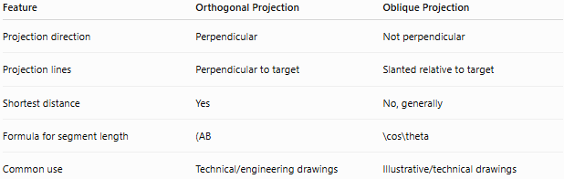
Feature | Orthogonal Projection | Oblique Projection
Projection direction | Perpendicular | Not perpendicular
Projection lines | Perpendicular to target | Slanted relative to target
Shortest distance | Yes | No, generally
Formula for segment length | (AB | \cos\theta
Common use | Technical/engineering drawings | Illustrative/technical drawings

Projection vs. Transformation
# Source: AI Source: Provided by: [Data Path: Persons Table -> ID Column: 1, Name_En Column: Motasem Essam] -> From: [ChatGPT] on [7/25/2026]
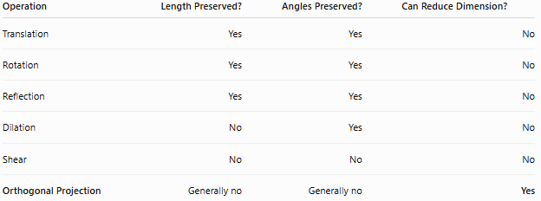
Operation | Length Preserved? | Angles Preserved? | Can Reduce Dimension?
Translation | Yes | Yes | No
Rotation | Yes | Yes | No
Reflection | Yes | Yes | No
Dilation | No | Yes | No
Shear | No | No | No
Orthogonal Projection | Generally no | Generally no | Yes
Projection is therefore different from the classical rigid transformations.

Applications
# Source: AI Source: Provided by: [Data Path: Persons Table -> ID Column: 1, Name_En Column: Motasem Essam] -> From: [ChatGPT] on [7/25/2026]
Projection of line segments is used in:
- Geometry — finding projected lengths.
- Trigonometry — cosine relationships.
- Vector mathematics — resolving vectors into components.
- Physics — resolving forces.
- Engineering — technical drawings.
- Architecture — orthographic views.
- Computer graphics — projecting objects onto screens.
- Robotics — spatial position calculations.
- Surveying — horizontal and vertical components.
- 3D modeling — representing 3D geometry in 2D.

Advantages
# Source: AI Source: Provided by: [Data Path: Persons Table -> ID Column: 1, Name_En Column: Motasem Essam] -> From: [ChatGPT] on [7/25/2026]
- Simplifies geometric problems.
- Provides a direct way to find directional components.
- Gives the shortest point-to-line distance.
- Useful for accurate technical representations.
- Has a simple trigonometric formula.
- Works naturally with vectors and coordinates.

Limitations
# Source: AI Source: Provided by: [Data Path: Persons Table -> ID Column: 1, Name_En Column: Motasem Essam] -> From: [ChatGPT] on [7/25/2026]
- Projected length is generally smaller than the original length.
- Angles are generally not preserved.
- Depth information can be lost.
- A segment can collapse to a point.
- Different spatial configurations can produce the same projection.

Comparison with Related Concepts
# Source: AI Source: Provided by: [Data Path: Persons Table -> ID Column: 1, Name_En Column: Motasem Essam] -> From: [ChatGPT] on [7/25/2026]
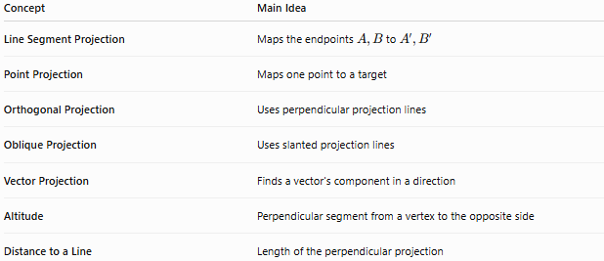
Concept | Main Idea
Line Segment Projection | Maps the endpoints $A,B$ to $A^{'},B^{'}$
Point Projection | Maps one point to a target
Orthogonal Projection | Uses perpendicular projection lines
Oblique Projection | Uses slanted projection lines
Vector Projection | Finds a vector's component in a direction
Altitude | Perpendicular segment from a vertex to the opposite side
Distance to a Line | Length of the perpendicular projection

Key Points
# Source: AI Source: Provided by: [Data Path: Persons Table -> ID Column: 1, Name_En Column: Motasem Essam] -> From: [ChatGPT] on [7/25/2026]
- The projection of $\overline{AB}$ is usually written as:
$$\boxed{\overline{A^{'}B^{'}}}$$
- $A^{'}$ and $B^{'}$ are the projections of $A$ and $B$.
- For orthogonal projection:
$$\boxed{AA^{'}⟂l, BB^{'}⟂l}$$
- The projected length is:
$$\boxed{A^{'}B^{'}=AB|cosθ|}$$
- If $AB∥l$:
$$\boxed{A^{'}B^{'}=AB}$$
- If $AB⟂l$:
$$\boxed{A^{'}B^{'}=0}$$
- Projection generally does not preserve lengths or angles.
- Projection onto coordinate axes gives the horizontal and vertical components.
- In a triangle, orthogonal projection onto the opposite side produces the foot of the altitude.

Conclusion
# Source: AI Source: Provided by: [Data Path: Persons Table -> ID Column: 1, Name_En Column: Motasem Essam] -> From: [ChatGPT] on [7/25/2026]
The Projection of a Line Segment is the segment obtained by projecting the endpoints of the original segment onto a target line or plane.
For an orthogonal projection:
$$\boxed{\overline{AB}→\overline{A^{'}B^{'}}}$$
and the projected length is:
$$\boxed{A^{'}B^{'}=AB|cosθ|}$$
The concept connects geometry, trigonometry, vectors, coordinate geometry, and technical drawing, and it provides an important way to understand how a segment behaves when viewed along a particular direction.

